Milestone 3 Report: CNNs and Transfer Learning for MedQuAD
Nov 7, 2026 · Mohammed Alabdullatif & Saleh Alrashdi

Summary
Transfer learning produced the best model of the project: a fine-tuned BART-base encoder used as a feature extractor for Ridge regression reached a test RMSE of 0.701, against 0.725 for the Milestone 2 shallow MLP and 0.823 for the Milestone 3 CNN trained from scratch. The same model ranks the correct answer first for 66.9% of test questions and in the top 5 for 84.5%.
Milestone 3 had two parts, both on the same task as Milestone 2: read a MedQuAD question and predict the 384-number embedding of its answer.
- Part 1 built a 1D text CNN from scratch, with tokenisation, data augmentation, hyperparameter tuning and early stopping.
- Part 2 transferred three pretrained seq2seq models (Flan-T5-small, BART-base, SciFive-base) in three ways: head only, last 3 layers, and extra layers. It saved the best model and used it as a feature extractor for four classical ML models.
All models share one data split, one target encoding and one test set, so their scores compare directly.

Task, data and evaluation
Every model reads a medical question and predicts the meaning of its answer as a vector. It does not write the answer text. The predicted vector can then retrieve the closest known answer, which is the retrieval step of a RAG system.
Data. Two public copies of MedQuAD (Hugging Face lavita/MedQuAD and a Kaggle copy) are merged to fill missing answers. The cleaning then:
- drops unused columns, rows with no answer, and duplicate question–answer pairs;
- removes question types with fewer than 10 rows.
That leaves 16,358 pairs. A stratified split by question type (random_state=42) gives 10,468 train / 2,618 validation / 3,272 test.
Targets. Each answer is encoded by the frozen all-MiniLM-L6-v2 sentence encoder into 384 numbers. These are standardised with a scaler fitted on training answers only. Milestone 2, Part 1 and Part 2 all use these identical targets.
Metrics.
- RMSE between predicted and true standardised vectors (lower is better). Always predicting the average answer scores 1.00, so that is the baseline.
- Top-1 / Top-5 retrieval accuracy and MRR (Part 2 only). Each prediction ranks all 3,164 distinct test answers by cosine similarity, and we check where the true answer lands. This shows directly whether a model would fetch the right answer.
Hyperparameters and checkpoints are always chosen on validation RMSE. The test set is used once per final model.

Part 1: CNN from scratch
The from-scratch CNN reached a test RMSE of 0.823 (MSE 0.677). It learned a clear signal, but stayed behind the Milestone 2 shallow MLP (0.725).
Input pipeline.
- Questions are lowercased and split into words and punctuation.
- The vocabulary is learned from training questions only. It keeps words seen at least twice, plus <PAD> and <UNK>, for 2,848 tokens (UNK rate 1.24%).
- Two augmentations triple the training set from 10,468 to 31,404 questions; each copy keeps its original answer target:
  - framing: prefixing "Please answer this question:";
  - rephrasing: rewriting the opening phrase, e.g. "What causes" to "What leads to".
- After adding the augmentation words, the vocabulary grows to 2,858 tokens. Questions are padded to 40 tokens.
Architecture (347,648 parameters).
- Embedding of 64 dimensions per token.
- Two Conv1d layers (64 filters, kernel 3) with ReLU.
- Max pooling, which halves the length from 40 to 20.
- Two Conv1d layers (128 filters, kernel 3) with ReLU.
- Global max pooling.
- Linear 128 → ReLU → Dropout → Linear 384.
The kernel-3 filters act as phrase detectors ("symptoms of", "what causes"). Global max pooling keeps the strongest response of each filter anywhere in the question.
Hyperparameter tuning (25 epochs, Adam, MSE, weight decay 1e-4).
Setting | Learning rate | Dropout | Best val RMSE
cnn_1 (selected) | 0.001 | 0.2 | 0.834
cnn_2 | 0.0005 | 0.2 | 0.845
cnn_3 | 0.0005 | 0.4 | 0.856
Early stopping. Retraining the best setting for up to 60 epochs with patience 7 improved validation RMSE from 0.834 to 0.825. The best epoch was 58, so patience never triggered: the model was still improving slowly, and the early-stopping checkpoint was selected and saved.
Why it trails the MLP. The CNN learns word meanings from about 2,850 words of in-domain text. Rare disease names often become <UNK>, which hides the word that decides the answer. The MLP instead started from MiniLM's pretrained question embeddings.

Part 2, steps 1–4: transfer learning from pretrained models
Unfreezing the last 3 encoder layers of BART-base gave the best neural model: test RMSE 0.723 and Top-1 retrieval of 65.1%. It was saved as the step 4 model.
Why seq2seq models instead of VGG19, ResNet or MobileNet. Those networks are pretrained on photos, while our input is text. We transferred from three pretrained text-to-text models instead. For each one we keep its encoder (the half that reads the question), average its token outputs into one vector, and replace the original next-word prediction head with a new head that outputs the 384 answer numbers.
Model | Pretrained on | Encoder parameters | Vector size
Flan-T5-small | General web text + instruction / Q&A tuning | 35.3M | 512
BART-base | General text (denoising) | 81.9M | 768
SciFive-base | PubMed abstracts + PMC papers (biomedical) | 109.6M | 768
How each step was trained. All steps use MSE loss, AdamW, the augmented 31,404 training questions, and early stopping on validation RMSE.
- Head only. The whole backbone is frozen; only a new Linear(d → 384) head is trained. Head learning rates of 1e-3, 3e-3 and 1e-2 were each trained fully, and the best on validation was kept.
- Last 3 layers. Everything is frozen except the last 3 encoder blocks and the head, which starts from the step 1 head. Pretrained layers need a much smaller learning rate than a new head, so they get their own rate. A 1-epoch search over 1e-5, 3e-5 and 1e-4 picked 1e-4 for all three models; the head stays at 1e-3. Each model then trained for 6 epochs.
- Extra layers. The backbone stays frozen. A deeper head is added: LayerNorm → FC 512 → GELU → Dropout 0.3 → FC 512 → GELU → Dropout 0.3 → FC 384. Learning rates of 3e-4 and 1e-3 were compared.
- Save the best. The best model–step pair was chosen by validation RMSE: BART-base, step 2 (0.7234). Its weights, tokenizer and settings were saved. Reloading it from disk gave the same validation RMSE, 0.7234, which confirms the saved copy is correct.
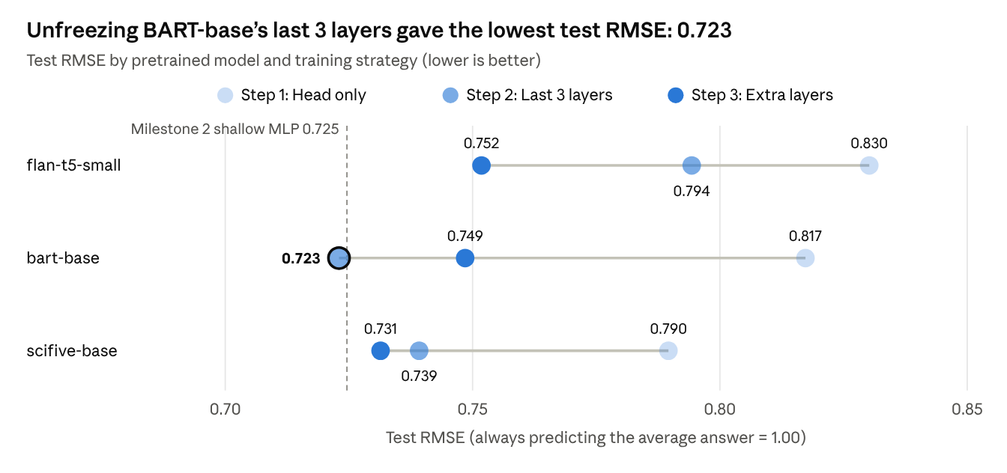
Milestone 3 Part 2 notebook, steps 1–3 · test set of 3,272 questions
Every model improved on head-only training. Unfreezing helped BART most (−0.094 RMSE). A deeper head helped the frozen Flan-T5 and SciFive most. Only BART step 2 reached the Milestone 2 MLP line.
Model | Step | Learning rate chosen | Trainable parameters | Top-1 | Top-5 | MRR
Flan-T5-small | 1 Head only | 1e-2 | 197K | 34.4% | 58.0% | 0.456
Flan-T5-small | 2 Last 3 layers | 1e-4 (head 1e-3) | 7.28M | 35.5% | 58.7% | 0.466
Flan-T5-small | 3 Extra layers | 1e-3 | 723K | 44.6% | 68.1% | 0.555
BART-base | 1 Head only | 3e-3 | 295K | 43.1% | 67.0% | 0.543
BART-base | 2 Last 3 layers | 1e-4 (head 1e-3) | 21.56M | 65.1% | 83.8% | 0.737
BART-base | 3 Extra layers | 1e-3 | 855K | 46.4% | 68.9% | 0.569
SciFive-base | 1 Head only | 1e-3 | 295K | 49.5% | 73.9% | 0.609
SciFive-base | 2 Last 3 layers | 1e-4 (head 1e-3) | 21.53M | 55.9% | 77.0% | 0.657
SciFive-base | 3 Extra layers | 3e-4 | 855K | 52.2% | 74.8% | 0.628
Retrieval follows RMSE closely, with one exception. Flan-T5's step 2 lowered RMSE but barely changed Top-1 (34.4% → 35.5%). With only 7.3M trainable parameters in a small model, the adapted layers learned the average shape of answers more than which specific answer fits.

Part 2, step 5: best model as a feature extractor
Ridge regression on the saved BART-base features is the best model in the project: test RMSE 0.701, which beats the model's own neural head (0.723).
The saved model (BART-base, last 3 layers fine-tuned) without its final linear layer turns each question into a 768-number feature vector. Four classical regressors were fitted on the 10,468 original training questions, each tuned on validation RMSE.
Model on BART-base features | Selected setting | Val RMSE | Test RMSE | Top-1 | Top-5 | MRR
Ridge regression | alpha = 1000 | 0.701 | 0.701 | 66.9% | 84.5% | 0.752
Neural head (step 2, reference) | – | 0.723 | 0.723 | 65.1% | 83.8% | 0.737
k-Nearest Neighbours (cosine) | k = 10 | 0.743 | 0.743 | 46.9% | 76.2% | 0.599
Linear SVM (LinearSVR) | C = 0.01 | 0.762 | 0.761 | 55.1% | 76.4% | 0.649
Random Forest (200 trees) | min leaf = 2 | 0.863 | 0.859 | 9.9% | 20.0% | 0.155
- Ridge wins because the fine-tuned features are already close to linearly related to the target. Its closed-form fit with strong L2 regularisation (alpha = 1000, the largest value tried) finds a better linear map than 6 epochs of gradient descent did.
- KNN answers a question by averaging the answers of its 10 most similar training questions. It gets close on RMSE but is weaker at ranking the exact answer first.
- Linear SVM and Random Forest have to predict 64 PCA components of the target instead of all 384, which keep 68% of the variance. This sets a floor of 0.566 test RMSE before any modelling error. Random Forest also splits on single features out of 768 dense dimensions, which suits this kind of embedding badly. Its predictions collapse towards the average answer, which is why it ranks the correct answer first only 9.9% of the time.

Comparison: Milestone 2 MLP vs CNN from scratch vs pretrained models
The ranking is: fine-tuned pretrained model > shallow MLP > scratch CNN. Ridge on fine-tuned BART features is 3.3% lower in RMSE than the shallow MLP and 14.8% lower than the scratch CNN.
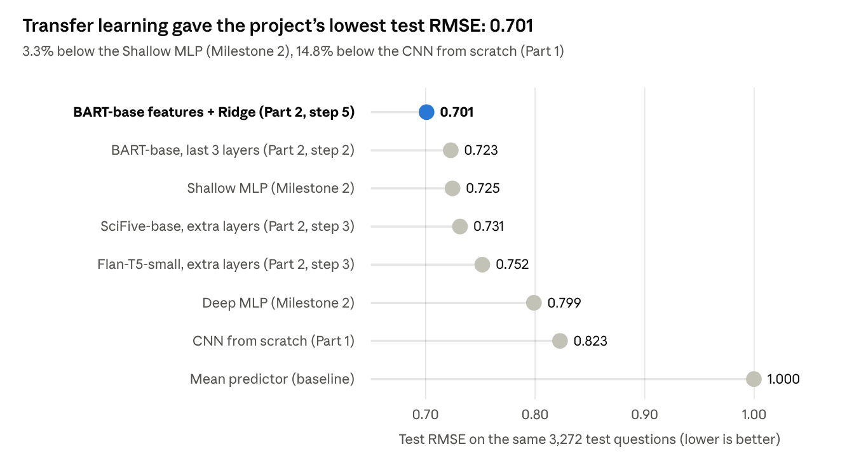
Milestone 2 notebook, Milestone 3 Part 1 and Part 2 notebooks · best result of each approach
All three phases used the same cleaned data, the same split (random_state=42), the same MiniLM answer targets and the same training-set scaler, so the RMSE values compare directly. The neural BART model on its own (0.723) is level with the shallow MLP (0.725). The gain comes from adding Ridge regression on its features.
Approach | Knowledge before training | What was trained | Trainable parameters
Shallow MLP (Milestone 2) | Pretrained MiniLM question embedding as input | 2 hidden layers (512, 256) | 427K
Deep MLP (Milestone 2) | Same as shallow MLP | 5 hidden layers | 1.0M
CNN from scratch (Part 1) | None: words learned from 10,468 questions | Embedding + 4 conv layers + head | 348K
BART-base, last 3 layers (Part 2) | 82M-parameter encoder pretrained on general text | Last 3 encoder blocks + head | 21.6M
BART-base features + Ridge (Part 2) | The fine-tuned BART encoder above | Linear map, solved in closed form | 295K coefficients
Only the Part 2 models also have retrieval scores. The Milestone 2 MLP and Part 1 CNN were scored on RMSE alone.

Discussion and conclusion
Pretrained knowledge, not network depth, decided the results.
- Pretraining beats training from scratch. Every Part 2 model with at least some adaptation (step 2 or 3) beats the scratch CNN, and the best is 15% lower in RMSE (0.701 vs 0.823). Frozen general-purpose features alone are not enough: Flan-T5-small with only a new head (0.830) is slightly worse than the scratch CNN.
- Adapting the backbone matters most. Unfreezing the last 3 layers gave BART-base the largest single gain in the project (0.817 → 0.723). On frozen backbones, a deeper head recovered much of that gap (0.830 → 0.752 for Flan-T5).
- Domain pretraining helps frozen features. SciFive, pretrained on PubMed, had the best frozen features (0.790 head only, 0.731 with extra layers). Once BART was allowed to adapt, it overtook SciFive.
- Why the shallow MLP is hard to beat. Its input is the question encoded by the same MiniLM model that encodes the target answers. Question and answer therefore start in the same vector space, a built-in advantage no other model had. The deep MLP (0.799) shows that adding layers to it did not help.
- Classical ML on good features can beat a neural head. Ridge on the fine-tuned BART features improved on its own neural head by 0.022 RMSE and 1.8 points of Top-1 accuracy.
Limitations.
- Model choice. The brief suggested image CNNs (VGG19, ResNet, MobileNet). Because our data is text, we used pretrained seq2seq text models instead. These are transformers, not convolutional networks.
- Step 2 training. Training was capped at 6 epochs, and validation RMSE was still falling at epoch 6 for all three models. The selected encoder learning rate (1e-4) was also the largest in the search grid. Longer training and a wider learning-rate search would likely improve step 2 further.
- Search limits. Some step 1 and 3 runs reached the 80-epoch cap. Ridge's best alpha was at the edge of its grid.
- Missing retrieval scores. Retrieval metrics were not computed for the Milestone 2 MLP or the Part 1 CNN, so those are compared on RMSE only.
- Single seed. Each result comes from one seed (42). Differences below about 0.005 RMSE should not be read as meaningful.
Conclusion. The project's best model is the BART-base encoder with its last 3 layers fine-tuned, used as a feature extractor for Ridge regression. Its test RMSE is 0.701, and it ranks the correct answer first 66.9% of the time and in the top 5 84.5% of the time among 3,164 candidate answers. That makes it the strongest candidate for the retrieval step of the MedQuAD question-answering system.

Github Repo Link: https://github.com/soilzx/MedQuAD-RAG.git

